**J24 Short Course Regatta**

**8 & 9 June 2024**

**Sailing Instructions**

**Preliminary Notice of Race**

**Organising Authority:**

**Manly Yacht Club**

**E-mail:** [sailingadmin@myc.org.au](mailto:sailingadmin@myc.org.au)

**On Behalf of**

**NSW J24 Association**

**And Thanks to our Sponsors**



**Event website:**

www.myc.org.au

**J24 Short Course Regatta 2024**

**Sailing Instructions**

**1. RULES**

1.1 The racing will be governed by the Racing Rules of Sailing (RRS), the Special Regulations of Australian Sailing (AS), the Regulations of NSW Maritime in regard to Ships and Ferries exclusion zones, and the International J24 Class Rules except as any of these are modified by these Sailing Instructions.

1.2. Changes to International J24 class rules:

1.2.1 Where a boat deviates from the rules of measurement on hull and rigging, such deviation may be considered legal when a class measurer is satisfied that the item in question is “as supplied by the licensed builder at the time of manufacture”. The measurement certificate shall be endorsed appropriately by the class measurer.

1.2.2 Class rule C.2.1(b) is changed as follows: A boat may sail with different crew on different days provided the crew changes are declared at registration. The number of declared crew shall remain the same throughout the regatta. Crew changes not declared at registration require advance written approval of the Race Committee and will only be approved in exceptional circumstances.

1.2.3 Class rule C.10.2 is changed as follows: A boat may carry one Mainsail, one Genoa, one Jib and two (2) Spinnakers on-board while racing.

1.3. Penalties when sailing:

1.3.1 The penalty for breaking a rule of Part 2 of the RRS shall be a One Turn Penalty (one tack and one gybe in the same direction) except that for infringements occurring within the Zone as defined in the current RRS the penalty shall be a Two Turns Penalty (two tacks and two gybes in the same direction). This changes RRS 44.1 and 44.2.

**2. NOTICES TO COMPETITORS**

Notices to competitors will be posted on the official online notice board <https://www.myc.org.au/notice-board/> and may be on the downstairs foyer noticeboard opposite the Manly Sailing.

**3. CHANGES TO SAILING INSTRUCTIONS**

Any changes to the sailing instructions will be posted before 0900hrs on the day they will take effect, except that any changes to the schedule of races will be posted by 2000hrs on the day before it will take effect.

**4. SIGNALS MADE ASHORE**

4.1. Signals made ashore will be displayed from MYC flagpole at the end of the jetty.

4.2 As a courtesy, the Race Committee may inform the fleet of relevant information via VHF Channel 72 and/or SMS messages.

4.3. When flag "AP" is displayed ashore,”1 minute is replaced with “not less than 30 minutes” in the race signal AP.

**5. BRIEFING**

Crew briefing will be held at MYC on Saturday 8 June at 10:30 am.

**6. SCHEDULE OF RACING**

6.1. The regatta will be held on Saturday 8 June and Sunday 9 June 2024.

6.2. There will be up to 5 races scheduled on each day with a maximum of 8 over the series.

6.3.1 The warning signal for the first start on Saturday 8 June will be no earlier than 1155 hrs.

6.3.2 The warning signal for the first start on Sunday 9 June will be no earlier than 1055 hrs.

6.4. Subsequent races will be started as soon as practicable after the completion of the previous race.

6.5. On the last scheduled day of racing no warning signal will be made after 1530hrs.

6.6. There will be no resails after Sunday 9 June 2024.

**7. CLASS FLAG**

7.1 J24 Class Flag will be a White flag with the J24 Class Insignia

**8. RACING AREA**

Racing will be conducted in the vicinity of Manly Yacht Club. The Racing Area on each day will be dependent on wind direction and explained at the Briefing.

**9. TIME LIMITS AND TARGET TIMES**

9.1. Race time limit – 80 minutes

9.2. Mark 1 time limit – 30 minutes

9.3. Race target time – 45 minutes

9.4. If no boat has passed Mark 1 within the time limit the race may be abandoned. Failure to meet the target time will not be grounds for redress. This changes RRS 62.1(a).

9.5. Boats failing to finish within 20 minutes after the first boat sails the course and finishes will be scored Did Not Finish without a hearing. This changes RRS 35, A4 and A5.

**10. THE COURSES**

10.1. The course diagram below shows the windward /leeward courses and the order in which marks are to be passed.

10.2. No later than the warning signal, the Race Committee signal vessel may display the approximate compass bearing of the windward mark for the first leg.

10.3. Courses will be advised by flying the appropriate numeral pennant with the Class Flag.

**Course Diagram**

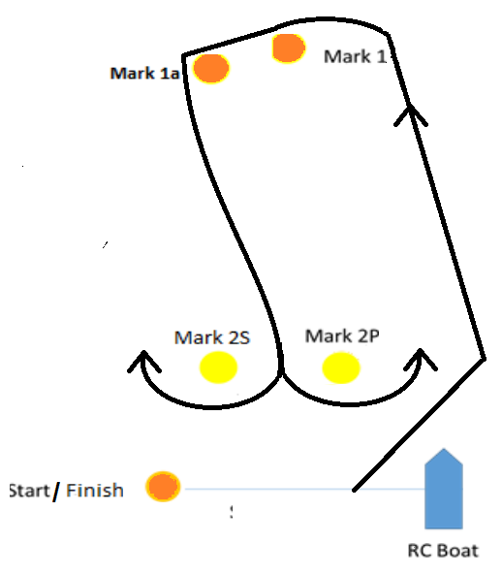

Course No Course Configuration

1 Start – 1 – 1a – Finish

2 Start – 1 – 1a – 2P/2S – 1 – 1a – Finish

3 Start – 1 – 1a – 2P/2S – 1 – 1a –2P/2S – 1 – 1a –Finish

10.4 On the finishing leg of the course, marks 2P and 2S are to be disregarded and are not marks of the course.

**11. MARKS**

11.1. Marks 1 and 1a will be orange spherical buoys.

11.2. Mark 1a will be an offset mark approximately 50 metres from Mark 1.

11.3. Marks 1, and 1a shall be rounded to Port.

11.5 Gate Marks 2P/2S will be yellow spherical buoys.

11.6. The Change Mark will be described at the briefing.

11.7. On any course where a mark is shown as a gate, if there is only one mark in place, it shall be rounded to Port.

**12. THE START**

12.1 Competitors should keep a listening watch on VHF Ch 72 for the Race Committee’s intentions regarding the start or course setting.

12.2 The starting line will be between the flagstaff on the Committee Boat at the starboard end and an orange spherical buoy at the port end.

12.3 When on station for the start, the Committee Boat shall fly a Manly Yacht Club burgee and an orange flag from the flagstaff.

11.4 A crowding mark may be laid adjacent to the Race Committee Boat. When laid, boats approaching the line to start shall leave the crowding mark on the same required side as the Race Committee Boat

11.5. A boat that does not start within 4 minutes after their starting signal will be scored DNS without a hearing. This changes RRS A4 and A5.

**13. CHANGE OF THE NEXT LEG OF THE COURSE**

13.1 To change the next leg of the course, the Race Committee will lay a new Change Mark (or move the finishing line) and remove the original mark as soon as practicable. When in a subsequent change a new mark is replaced, it will be replaced by an original mark.

**14. THE FINISH**

13.1 The finishing line will be between the Committee Boat flagstaff and an orange spherical buoy at the starboard end of the line.

10.6 When on station for the finish, the Committee Boat will fly the MYC Burgee and a Blue Flag from the flagstaff.

**15. PROTESTS AND REQUESTS FOR REDRESS**

15.1. Protest forms are available at <https://www.myc.org.au/wp-content/uploads/ProtestForm.pdf>. Protests and requests for redress or reopening shall be delivered to the sailing office upstairs at Manly Yacht Club within the appropriate time limit.

15.2. The protest time limit is 60 minutes after the last boat has finished the last race of the

day or the time limit expiry or the Race Committee signals no more racing today, whichever is later.

15.3. Notices will be posted on the Online Notice Board no later than 30 minutes after the protest time limit to inform competitors of hearings in which they are parties or named as witnesses.

15.4. Notices of protests by the Race Committee or Protest Committee will be posted to inform boats under RRS 61.1(b).

15.5. Breaches of SIs 19, 21, 22, 23 and 24, will not be grounds for a protest by a boat. This changes RRS 60.1(a).

15.6. On the last scheduled day of racing a request for redress based on a Protest Committee decision shall be delivered no later than 30 minutes after the decision was posted. This changes RRS 62.2.

**16. PENALTIES**

16.1 When the Protest Committee decides that a boat that is a party to a protest has broken a rule it shall disqualify her per RRS 64.2, unless the rule broken is one of the class rules listed in Attachment 1, for which the applicable percentage scoring penalty is prescribed therein, calculated in accordance with RRS 44.3 (c).

**17. ARBITRATION**

17.1. Appendix T will apply.

17.2. The arbitrator may be a member of any subsequent Protest Committee or may observe and give evidence to a Protest Committee.

**18. SCORING**

18.1. The Low Point scoring system, Appendix A of the RRS will apply.

18.2. Four (4) completed races are required to constitute a series.

18.3. Each boat’s series score will be the total of her race scores with one drop allowed or 2 drops if more than 6 races are sailed.

18.4 Performance Handicap System (PHS) results will be decided by application of a Time Correction Factor (TCF). The PHS TCF allocated by the Race Committee, will be re-calculated between races and will not be subject to redress. This changes rule RRS 62.1(a).

**19. SAFETY**

19.1. All competitors are reminded that they are responsible for their own personal safety, as per RRS 1.2, irrespective of signals made or not made.

19.2. A boat that retires from a race shall notify the Race Committee as soon as possible.

**20. REPLACEMENT OF CREW OR EQUIPMENT**

20.1. Substitution of competitors will not be allowed without prior written approval of the Race Committee.

20.2. Substitution of damaged or lost equipment will not be allowed unless authorised by the Race Committee. Requests for substitution shall be made to the Race Committee at the first reasonable opportunity.

**21. EQUIPMENT AND MEASUREMENT CHECKS**

21.1 On the water, a boat can be instructed by a member of the Race Committee to proceed immediately to a designated area for inspection. Ashore, equipment may be inspected or measured at times specified in the class rules, the notice of race, or within 60 minutes after the last boat has finished the last race of the day or the Race Committee signals no more racing today, whichever is later.

**22. HAUL-OUT RESTRICTIONS**

22.1. Boats shall remain in the water from 0900 hrs on Saturday 8 June until the completion of the racing.

22.2. The Race Committee may approve a written request for a boat to be hauled out at any time provided it is satisfied that this is required for essential repairs. Haul-out approval is only to facilitate work that could not have been done afloat.

22.3. The Race Committee may approve a written request for a boat to be launched later than 0900hrs on Saturday 8 June provided it is satisfied that this is for genuine reasons.

**23. PLASTIC POOLS AND DIVING EQUIPMENT**

23.1 Underwater breathing apparatus, closed plastic pools or their equivalent shall not be used around boats from 1000hrs on Saturday 8 June 2024 until the completion of the regatta.

**24. RADIO COMMUNICATION**

24.1 Except in an emergency, a boat while racing shall neither make nor receive electronic transmissions (radio, e-mails, mobile phone etc.) or other communications which are not available to all boats.

24.2 Boats shall maintain a listening watch on the designated race frequency VHF Ch 72. Boats may transmit on VHF radio to communicate in the event of an emergency or upon retiring from a race or at the request of the Race Committee.

**25. DISCLAIMER OF LIABILITY**

25.1. All those taking part in races conducted by Manly Yacht Club do so at their own risk and responsibility. Manly Yacht Club, its staff, officers, and volunteers accept no responsibility whatsoever for the seaworthiness of boats whose entries are accepted or the sufficiency or adequacy of its equipment.

25.2. Attention is drawn to RRS Fundamental Rule 3, Decision to Race: The responsibility for a boat’s decision to participate in a race or to continue racing is hers alone.

25.3. Manly Yacht Club, its staff, officers, and volunteers accept no responsibility whatsoever for loss or damage to boats or equipment or personal injury or death associated with races conducted by the Club.

**ATTACHMENT 1** — Penalties for Breaking Some Class Rules

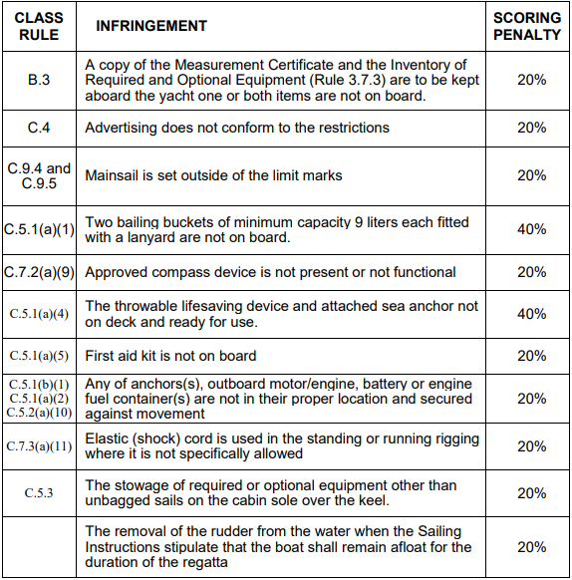

If a boat receives one of the above penalties, the protest decision will include whether the same

penalty can or will be applied to subsequent infringements. The protest decision may also specify

that the boat cannot be protested again under the same class rule for a time period specified by

the Protest Committee.