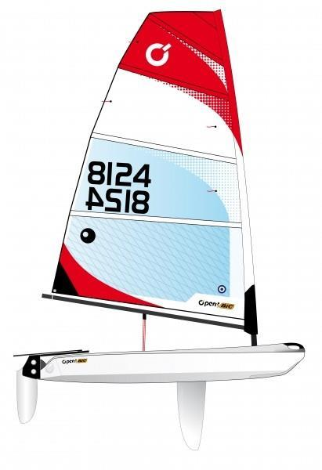

2023
Manly Cup
for Open Skiffs and Youth Lasers (ILCA 4 & 6)

2nd - 3rd December 2023

NOTICE OF RACE

Organising Authority

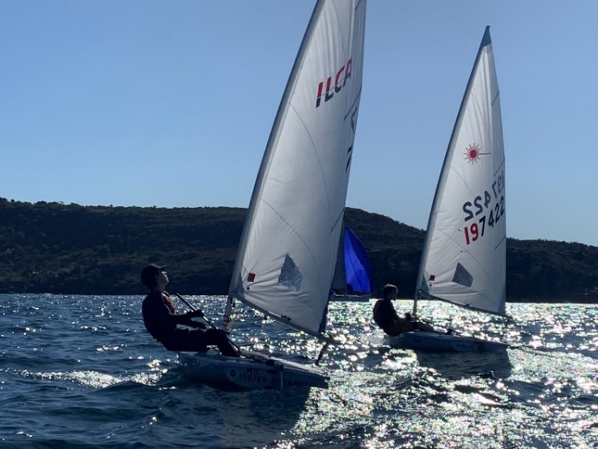

RULES
The regatta will be governed by the rules as defined in the Racing Rules of Sailing 2021-2024 (RRS).

Australian Sailing Special Regulations - Part 2 (for off the beach boats) shall apply. It is the responsibility of all competitors to ensure that life jackets comply with a standard equivalent to those listed in the regulations.
It is recommended that competitors wear a safety helmet to the minimum standard of EN1385 or EN1077 whilst afloat.

  - Gold Fleet
World Sailing Appendix UF as modified by Australian Sailing for O’pen Skiff events shall apply. Refer to Attachment #4
  - Silver Fleet
The regatta will be governed by the World Sailing Introductory Rules for Racing. Refer to Attachment #3
  - Green Fleet
Refer to Attachment #2.
  - ILCA 4 and 6 Fleets
The event is governed by the rules as defined in The Racing Rules of Sailing.

- ADVERTISING
  - Boats may be required to display advertising chosen and supplied by the organising authority.
  - The organising authority reserves the right to refuse advertising by a boat or competitor when it is in conflict with an event sponsor or government regulations.
- ELIGIBILITY AND ENTRY
  - The regatta is open to boats complying with the current O’pen Skiff class and International Laser Class Association (ILCA) rules for ILCA 4 (4.7) and ILCA 6 (Radial) rigs.
  - The regatta is a youth event for sailors up to 17 years old. If you are unsure of eligibility, please contact the race organisers.
  - Open Skiff class boats may be available for charter. The charter fee is $160 and can be booked online during entry.
  - The use of the North Sails manufactured, 3.2m Russell Coutts training sail, is allowed for Silver and Green Fleets (Open Skiff only).
  - All sailors shall be financial members of a yacht club that is affiliated with Australian Sailing or their MNA.
  - Each boat shall be covered for a minimum $10 million of third-party liability insurance. MSC requires all boats participating in aquatic events provide evidence of insurance cover both on shore and while racing.
  - Competitors and guardians shall abide by the Australian Sailing Member Protection Policy and Procedures.
  - Entry into Silver and Green Fleet shall be approved by Manly Yacht Club.
  - Entry prior to (and including) 12 November 2023 is $100
Entry after 12 November 2023 is $120
Entries close on 29 November 2023
  - Boats shall enter online at https://raceroster.com/events/2023/81378/2023-manly-cup and pay the relevant entry fee.
  - If the event the event is abandoned due to COVID-19 restrictions, a full refund will be provided.

- PROPOSED SCHEDULE (NOTE: An updated version may be available at registration)

Date | Time | Event
Friday 1 December | 1600 - 1800 | Registration & Charter boats available
Saturday 2 December | 0800 - 1000 | Registration & Charter boats available
 | 1000 | Competitor briefing
 | 1100 | Racing/On water activities
 | 1800 | BBQ Dinner at the club
Sunday 3 December | 0930 | Competitor briefing
 | 1000 | On water activities
 | Asap after sailing | Prize Giving

  - A number of non-scoring adventure type races may be sailed during the event when conditions are appropriate
  - No warning signal will be made after 1500hours on Sunday 3 December.
  - Our traditional Christmas dress up theme fun race (with prizes for best dressed) will occur on Sunday 3 December.

- MEASUREMENT
A boat or equipment may be inspected at any time for compliance with the rules as defined in the RRS.
- SAILING INSTRUCTIONS
Sailing Instructions (Sis) will be posted online prior to the event. Sis will be posted on the Official Notice Board. Other documents governing the event may be published with the Sailing Instructions.

- VENUE AND COURSE AREA

  - The regatta will be conducted at Manly Yacht Club on the waters of Sydney Harbour as shown in Attachment 1.
- COURSES
  - Will be a mixture of windward/leeward, trapezoid or slalom as described in the sailing instructions.
  - The target time for each race is 25 minutes.
- SCORING
  - The Low Point Scoring system of RRS Appendix A will apply.
  - 3 races shall be completed to constitute a series.
  - A boat may drop her worst score after 4 races and her worst 2 scores after 8 races are completed.
- SUPPORT BOATS
  - All support boats shall register with Manly Yacht Club and may be required to display an identifying flag which will be provided at registration. Life jackets are to be worn by all personnel on registered support vessels.
  - Support boats shall be covered for a minimum $10 million of third-party liability insurance. Proof of cover may be required at registration.
  - Support boats are requested to monitor the course VHF channel for safety information, provide assistance, if requested and follow any instructions given by the race officer.
  - Support boats shall remain at least 50m outside the course area unless providing safety assistance to a competitor.
  - Silver and Green fleet boats may receive coaching assistance from the official coach boat(s) and any such communication shall not be considered outside help. This changes rule 41.

- TRAILER PARKING
  - All trailers may be stored in the areas designated by the Host Club. Any trailers left within the boat park may be moved / relocated at the discretion of the Organising Authority/Host Club.

- RADIO COMMUNICATIONS
Except in an emergency, a boat shall neither make nor receive radio transmissions, text messages or cellular phone calls while afloat except in an emergency or when using equipment provided by the race committee.

- MEDIA RIGHTS
In participating in this event, a competitor or their guardian automatically grants to the organising authority and the sponsors of the event, the right in perpetuity, to make, use and show, from time to time and at their discretion, any motion pictures, still pictures and live, taped or film television and other reproductions of him/her during the period of the competition for the said event in which the competitor participates and in all material related to the said event without compensation.
- PRIZES
ILCA 4 (4.7 Rig)
Overall: 1st, 2nd, 3rd

ILCA 6 (Radial Rig)
Overall: 1st, 2nd, 3rd

Gold Fleet
Overall: 1st (winner of Manly Cup), 2nd, 3rd
U12 (as at 1st day of regatta): 1^{st ,} 2nd, 3rd
U15 (as at 1st day of regatta): 1^{st ,} 2nd, 3rd

Silver Fleet
Overall: 1st , 2nd, 3rd
U12 (as at 1st day of regatta): 1^{st ,} 2nd, 3rd
U15 (as at 1st day of regatta): 1^{st ,} 2nd, 3rd

Green Fleet – Prizes may be awarded for ‘encouragement’ and ‘taking part’ as well as placing for positions.

Other prizes may be awarded by the Organising Authority.

- DISCLAIMER OF LIABILITY
Competitors participate in the event entirely at their own risk (refer RRS 4 – Decision to Race). The organizing authority will not accept any liability for material damage, personal injury or death sustained in conjunction with, prior to, during, or after the event.
The boat’s decision to enter will be considered to be testament that:-
- the boat complies with the event entry eligibility requirements within this Notice of Race;
- the skipper fully understands the meaning and intent of the RRS PART 1 – FUNDAMENTAL RULES;
- the skipper has the necessary knowledge and skills to safely participate in and complete the event
- the participants indemnify the organizing authority, its agents and volunteers from any responsibility for any matter relating to the boat’s participation in the event.
This consideration is made in relation to the application of the Civil Liability Act 2003 to dangerous recreational activities.
- FURTHER INFORMATION
For further information, please contact:
Manly Yacht Club
Ph. 02 (02) 9977 4949 or Email: info@myc.org.au or Geoff Gill at: gegill@deloitte.com.au
- LIST OF ATTACHMENTS
Attachment 1 – Club location and sailing area
Attachment 2 – Green fleet Guidelines
Attachment 3 – Introductory Rules for Racing
Attachment 4 – Appendix UF – Umpired Fleet Racing
Attachment 1:
Regatta Venue and Racing area

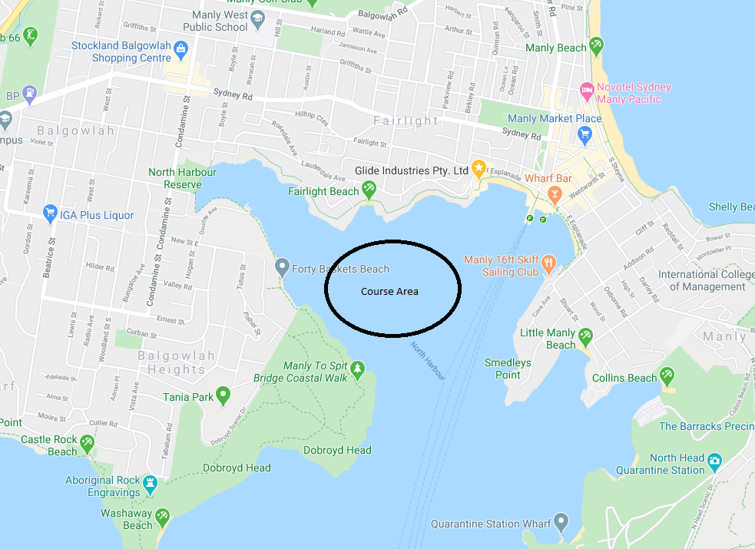
Manly Yacht Club

Attachment 2:
Green Fleet Guidelines

- In the Green Fleet emphasis is on fun. The objective of this regatta is to offer younger and less experienced sailors the opportunity to sail and participate at the O’pen Skiff events without feeling the need or burden to sail in the more competitive and arduous Gold and Silver Fleets.

- Sailing will be a mixture of adventure sailing, racing, freestyle and any other form of sailing that the organisers deem fit.

- Sailors will benefit from a high level of coaching throughout the event.

- Sailors entering the Green Fleet should be of a level of sailing similar and/or equal to Tackers 2.

- Green Fleet racing is intended to be run dependent on weather forecasts and prevailing winds. Should the conditions be such that racing is an option this will be conducted on a separate course.

- The Green Fleet will consist of a variety of activities, led by appropriately qualified activity leaders/rules advisors (in an approximate ratio of 1:10 on the water). These activities may include both shore and on-water based skills, coaching and on-water games.

- Prizes may be awarded for ‘encouragement’ and ‘taking part’ as well as placing for positions. Prizes will be awarded at the discretion of the Organising Authority.

- Parents, guardians and friends are encouraged to come and spectate but please refrain from coaching/communicating with sailors and allow the qualified coaches to deal with any issues/circumstances that arise.

Attachment 3:
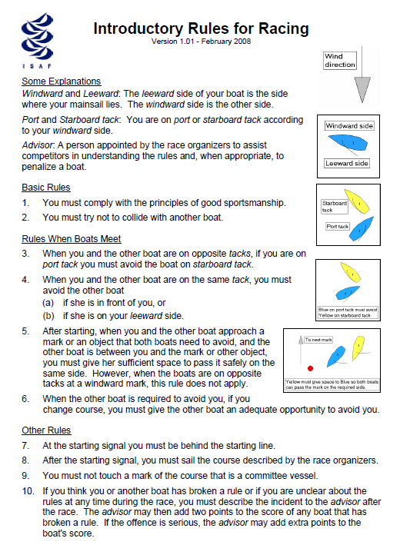

Attachment 4:
APPENDIX UF

O’PEN Skiff UMPIRED FLEET RACING RULES

APPENDIX UF UMPIRED FLEET RACING
Australian Open Skiff Edition
Version: November 2021
Umpired fleet races shall be sailed under The Racing Rules of Sailing as changed by this appendix. Races shall be umpired. The rule changes in UF1 have been approved by World Sailing under Regulation 28.1.5(b) on the condition that only the provided options are used. This appendix applies only when it is referred to in the Notice of Race and made available for all competitors.
Competitors are encouraged to ask the Umpires after racing about a decision made on the water to assist with learning outcomes. This can be done between races or on shore. Attempt to identify the umpire that made the decision to speak with about the incident.
UF1 CHANGES TO THE DEFINITIONS, THE RULES OF PART 1 AND 2, AND RULE 70
UF1.1 Add to the definition Proper Course: ‘A boat taking a penalty or manoeuvring to take a penalty is not sailing a proper course.’
UF1.2 Add new rule 7 to Part 1:
7 LAST POINT OF CERTAINTY
The umpires will assume that the state of a boat, or her relationship to another boat, has not changed, until they are certain that it has changed.’
UF1.3 Blank
UF1.4 When rule 20 applies, the following arm signals are required in addition to the hails:
(a) for room to tack, repeatedly and clearly pointing to windward; and
(b) for ‘You tack’, repeatedly and clearly pointing at the other boat and waving the arm to windward.
UF1.5 Rule 70 is deleted.
UF2 CHANGES TO OTHER RULES
UF2.2 Rule 31 is changed to:
31 TOUCHING A MARK
While racing, a boat’s hull shall not touch a starting mark before starting, a mark that begins, bounds or ends the leg of the course on which she is sailing, or a finishing mark after finishing.
UF3 ON WATER PROTESTS AND PENALTIES
UF3.1 In this appendix, ‘a penalty’ will mean the following:
If a boat promptly acknowledges breaking a rule: A One-Turn Penalty taken in accordance with rule 44.2; or
If an umpire penalizes a boat: A Two-Turn Penalty taken in accordance with rule 44.2.
UF3.2 The first sentence of rule 44.1 is changed to: ‘A boat may take a penalty when, in an incident while racing, she may have broken one or more of the rules of Part 2 (except rule 14 when she has caused damage or injury), rule 31 or rule 42. However, when she may have broken a rule of Part 2 and rule 31 in the same incident, she need not take the penalty for breaking rule 31’
UF3.3 On the Water Protests by Boats and Penalties
(a) While racing, a boat may protest another boat under a rule of Part 2 (except rule 14) or under rule 31 or rule 42; however, a boat may only protest under a rule of Part 2 for an incident in which she was involved. To do so she shall hail ‘Protest’, raise a hand in the air, and identify the other boat(s) involved at the first reasonable opportunity for each.
(b) A boat that protests as provided in rule UF3.3(a) is not entitled to a hearing. Instead, a boat involved in the incident may acknowledge breaking a rule by voluntarily taking a penalty. An umpire may penalize any boat that broke a rule and was not exonerated, unless the boat took a penalty voluntarily.
UF3.4 Penalties and Protests Initiated by an Umpire
(a) When a boat
(1) breaks rule 31 and does not take a penalty,
(2) breaks rule 42,
(3) gains an advantage despite taking a penalty,
(4) commits a breach of sportsmanship, or
(5) fails to comply with rule UF3.6 or to take a penalty when required to do so by an umpire,
(6) breaks a rule of Part 2 and there is physical contact
an umpire may penalize her without a protest by another boat. The umpire may impose a penalty or more, each signalled in accordance with rule UF3.5(b), or disqualify her under rule UF3.5(c), or report the incident to the protest committee for further action. If a boat is penalized under rule UF3.4(a)(5) for not taking a penalty or taking a penalty incorrectly, the original penalty is cancelled,
(b) An umpire who decides, based on his own observation or a report received from any source, that a boat may have broken a rule, other than rule UF3.6 or a rule listed in rule UF3.3(a), may inform the protest committee for its action under rule 60.3. However, he will not inform the protest committee of an alleged breach of rule 14 unless there is damage or injury.
UF3.5 Umpire Signals
An umpire will signal a decision as follows:
(a) A green and white flag with one long sound means ‘No penalty.’
(b) A red flag with one long sound means ‘a penalty is imposed or remains outstanding.’ The umpire will hail or signal to identify each such boat.
(c) A black flag with one long sound means ‘A boat is disqualified.’ The umpire will hail or signal to identify the boat disqualified.
UF3.6 Imposed Penalties
(a) A boat penalized under rule UF3.5(b) shall take a penalty.
(b) A boat disqualified under rule UF3.5(c) shall promptly leave the course area.
UF4 RACE COMMITTEE ACTIONS
UF4.1 After boats have finished, the race committee will inform competitors about the results on the official noticeboard.
UF5 PROTESTS; REQUESTS FOR REDRESS OR REOPENING; APPEALS; OTHER PROCEEDINGS
UF5.1 No proceedings of any kind may be taken in relation to any action or non-action by an umpire.
UF5.3 A boat intending to
(a) protest another boat under a rule other than rule UF3.6, or a rule listed in rule UF3.3(a),
(b) protest another boat under rule 14 if there was contact that caused damage or injury, or
(c) request redress
shall inform the race committee or an Umpire within two minutes of finishing.

UF5.5 The race committee will promptly inform the protest committee about any protests or requests for redress made under rule UF5.3.
UF5.6 The third sentence of rule 61.1(a), all of rule 62.1(a), and all of rule 61.1(a)(2) are deleted.
UF5.7 The first three sentences of rule 64.2 are changed to: ‘When the protest committee decides that a boat that is a party to a protest hearing has broken a rule, it may impose penalties other than disqualification, and may make any other scoring arrangement it decides is equitable. If a boat has broken a rule when not racing, the protest committee shall decide whether to apply any penalty to the race sailed nearest in time to that of the incident or make some other arrangement.’
UF5.8 Hearings
Except for a hearing under rule 69.2
(a) Protests and requests for redress need not be in writing.
(b) The protest committee may inform the protestee and schedule the hearing in any way it considers appropriate and may communicate this orally.
(c) The protest committee may take evidence and conduct the hearing in any way it considers appropriate and may communicate its decision orally.
(d) If the protest committee decides that a breach of a rule has had no effect on the outcome of the race, it may impose a scoring penalty of points or fraction of points or make any other arrangement it decides is fair, which may be to impose no penalty.
(e) If the protest committee penalizes a boat in accordance with rule UF5.7 or if a standard penalty is applied, all other boats will be informed about the change of the penalized boat’s score.
UF5.10 The protest committee may protest a boat under rule 60.3. However, it will not protest a boat for breaking rule UF3.6, a rule listed in rule UF3.3(a), or rule 14 unless there is damage or injury.
UF5.12 Rule 66.2 is changed to ‘A party to the hearing under this appendix may not request a reopening.’

